Values Populated in BAPI_ACC_DOCUMENT_POST for posting FI documents for freely defined Currency:

Header Table:

Username: DE8555

Company Code: 1153

Document Date: 01.04.2019

Posting Date: 01.04.2019

Fiscal Year : 2019

Period: 08

Document Type: SA

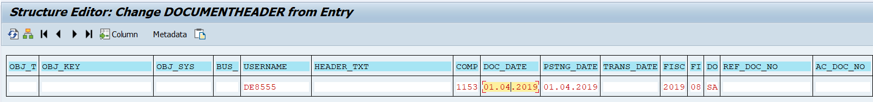

Line Item Data:

GL Line Item:

Line Item 1:

Item No: 0000000001

GL Account: 0010055000

Item Test: Test

Account Type: S

Document Type: SA

Company Code : 1153

Period: 08

Fiscal Year: 2019

Posting Date: 01.04.2019

Profit Centre: AD58437

Item No: 0000000002

GL Account: 0068500000

Item Test: Test

Account Type: S

Document Type: SA

Company Code : 1153

Period: 08

Fiscal Year: 2019

Posting Date: 01.04.2019

Cost Centre: DE58QP1000

Profit Centre: AD58437

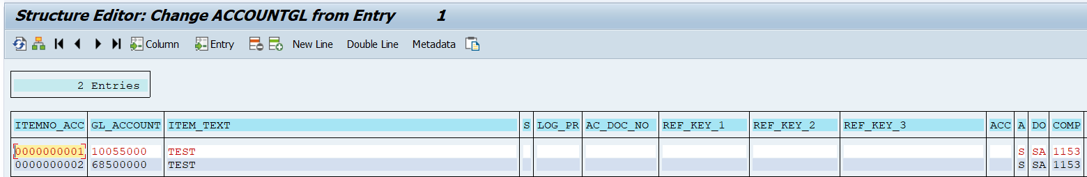

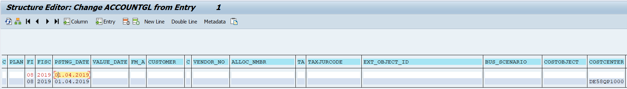

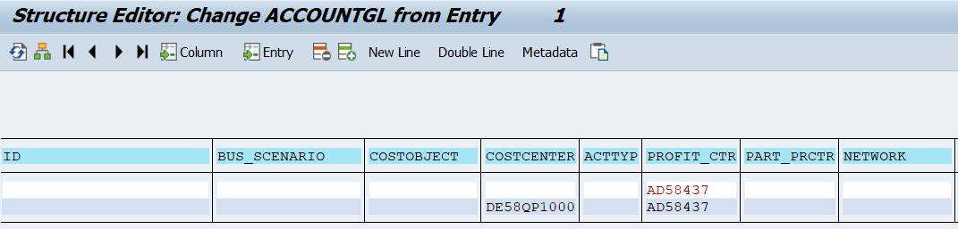

Currency Amount Table:

Item No: 0000000001

Currency Type: Z1

Currency: EUR

Amount in Document Currency: 10.0000

Item No: 0000000002

Currency Type: Z1

Currency: EUR

Amount in Document Currency: -10.0000

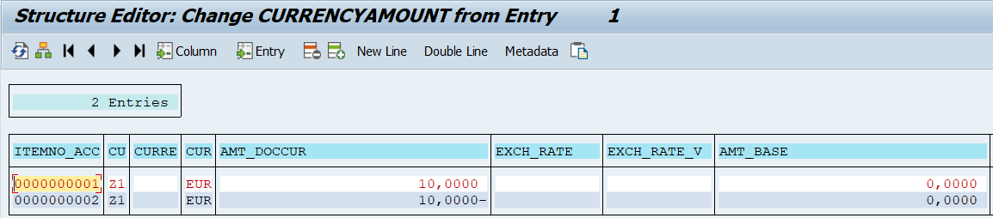

After execution Getting Following Error:

